Every comic fan has stories they love to go back and reread, the ones that mean a little something special or are just so good you can’t help but return to them. I know I do, as there are a slew of comics – including single issues, runs, arcs, strips, etc. – that I can’t help but come back to every once in a while. That’s what Revisitor is going to be all about, as this new recurring column is going to look back on the stories we can’t help but revisit, occasionally working in perspective from the people who made these comics we can’t help but love.

And this new column is starting in the perfect place, as we’ll be looking back at the comic book equivalent of comfort food for yours truly – I reread it sometimes when I’m having a tough day and it never fails to put a smile on my face - that just so happened to turn 20 years old last month. It’s “Pancakes,” a hilarious two-page Hellboy story from the August 1999 Dark Horse Presents Annual. Even better? I’ll be getting a little insight from the man behind that brilliant comic, as Mike Mignola shared some perspective on how this delightfully quirky entry into the Hellboy oeuvre came to be.

So why’s it an all-timer for me, and a title I can’t help but revisit time and time again? Well…it’s partially because it’s kind of an anomaly, right? Hellboy is a comic that has long had humor as an aspect of it, but it’s hardly what I’d call a “funny” comic overall. Haunting? Yes. Entertaining? Absolutely. Poetic and arresting? Of course. But by and large, comedy is an element that doesn’t define the series, especially when you consider the whole. Most of the funniest parts of the series are small sequences or even just panels within issues and arcs, with arguably the most commonly cited humorous beat – besides “Pancakes,” of course – being the famously meme-worhy “Is that a monkey?” “He’s got a gun!” from Box Full of Evil, which also happened to arrive in August of 1999.

But “Pancakes”? It’s all funny, even following a pretty classic joke structure of first page setup, second page punchline. Let’s take a look at the first page real quick to see that in action.

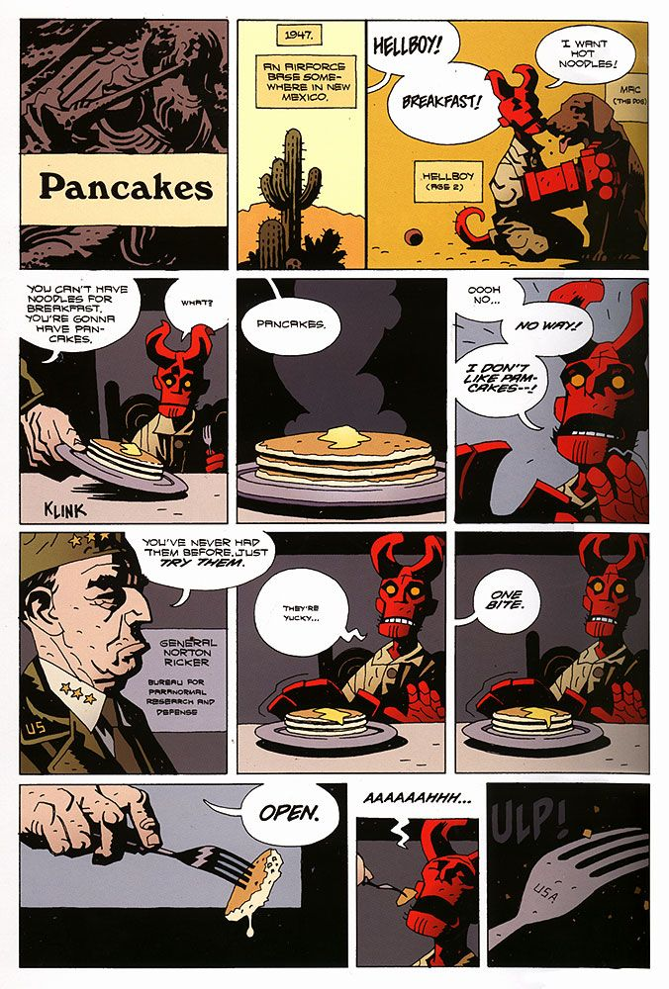

Like I said, it’s all setup. The page even ends with the action being committed to, with the page turn revealing the result of eating of said “pamcake,” even if said result isn’t the true punchline that sells the whole thing. But this page is a requirement to make that hammer to hit, as even readers who aren’t super familiar with the character are delivered everything they need to make the whole thing work just on this page.

Who is Hellboy? He’s a young kid, and one that sure looks like a demon of some sort. What’s he like? A typical kid, as he’s being picky as heck about breakfast, desiring something besides what he’s been given. What’s he doing? Being forced into it by a General at the Air Force base he resides at that’s at least *somewhat* responsible for him. It’s 12 quick panels of informational download that also charmingly sets up the gag to follow. It’s economical comic book storytelling at its finest.

Let’s look at the punchline now.

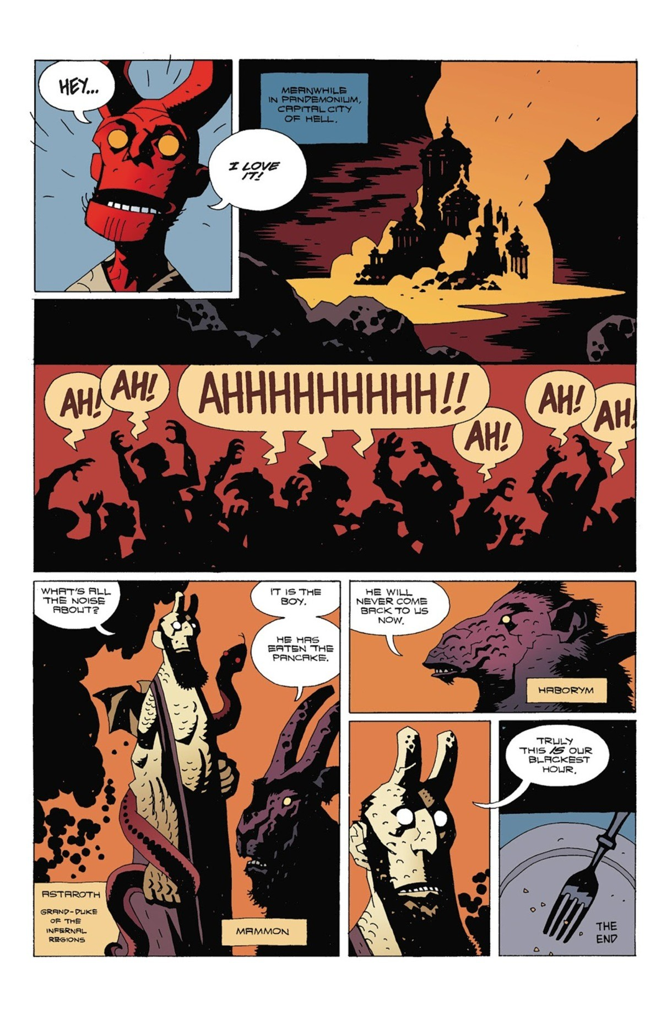

Of course Hellboy loves pancakes, because he’s a kid and it turns out that fluffy discs of batter covered in butter are in fact right up the alley of most children. But that’s not the punchline, as unlike most kids, Hellboy is a half-demon whose destiny may or may not be to free the Ogdru Jahad [footnote]Some Lovecraftian monsters that can only be loosed upon the world with Hellboy’s assistance.[/footnote] with his Right Hand of Doom. The residents of Hell are invested in Hellboy eventually realizing that fate. Or at least they are until he has “eaten the pancake,” an action that ensured “he will never come back to (them) now,” if only because pancakes are delicious and who wants to release monsters into the world when that would limit access to said pancakes?

Everything about these two pages and 19 panels is perfect, as Mignola’s natural pace as a storyteller isn’t just effective at telling haunting, thoughtful tales of adventure, but gags as well. The cadence makes every panel hit extra hard, especially when it comes to the final four panels. A completely sincere “Truly this is our blackest hour” coming from a Grand Duke of the Infernal Regions [footnote]aka Astaroth, a character that becomes much more important later on for non-pancake reasons.[/footnote] is a beautifully funny beat, especially when followed by a cleaned plate.

Interestingly, though, this beloved two-pager was effectively a by-product of Mignola trying to get out of the gig. The editor of Dark Horse Presents called him explaining that they were doing a special issue – called DHP, Jr. – filled with short comics about Dark Horse characters when they were young. The editor wanted to see if Mignola would be down with telling a young Hellboy story in it.

“I didn’t want to do it, had no intention to do it, but as a joke I said something like ‘How about two pages of Hellboy eating pancakes?’ It was a silly idea and meant to mean that I didn’t want to do a story, but the editor right away said ‘okay,’ and there you go—I was stuck,” Mignola told me. “At the time my very young daughter seemed to eat pretty much nothing but hot noodles with butter, and if you tried to feed her anything else she’d go rigid, like you’d just put a snake on her plate.

“So I decided to just do something like that with Hellboy.”

As a breakfast obsessed human, there was a part of me that always wondered one specific question about this comic: why pancakes? There are so many delicious food options available to woo Hellboy away from the forces of Hell. How did it end up being that food in specific? It wasn’t complicated, really.

“I don’t really remember why pancakes—it’s just what popped into my head when that editor called. Maybe we’d tried to get our daughter to eat pancakes,” Mignola said. “I do remember that I didn’t think of any other food. I didn’t really give it that much thought.”

So the fussy eater angle was easy to figure out. Mignola knew what he wanted to do there from the jump, but that was one page, tops, and it wasn’t really a complete story by any means. It needed some sort of payoff.

“I didn’t know where to go after the first pages and then came up with the cut-away to hell, just because I thought it would be funny,” Mignola shared.

The funny thing about that second page is it’s the kind of beat that you can make up however much depth to as you’d like. It could be a statement about Hellboy’s position as a figure of destiny! You could say that pacnake changed his life forever, pushing him to the side of the angels for good! It’s cited as Astaroth’s first appearance, so maybe it’s important in that way! Nah. It’s nothing like.

“I was not giving any thought at all to Hellboy’s destiny—not much thought at all about anything. I just thought it would be a good, fast gag,” Mignola said. “At the time I wasn’t even thinking it would ever be reprinted, it would just be an odd little curiosity.”

**This comic was just a quick gag, but it’s also become a beloved part of the larger Hellboy world for fans. Are you ever surprised by readers (and even film directors) latching onto this story in particular, or is that kind of thing just impossible to predict?**

You never really know what’s going to click with people. The pancake thing has clearly taken on a life of its own—it gets referenced by fans all the time. I’ve gotten used to it. I’ve made my peace with it.